Custom AMI & Launch Template
We can create a new server from an existing server by using templates in AWS.
A template is nothing but a copy of a existing server .
It’s used in ASG (Auto Scaling Group ), where there is a high demand but we have less resources/servers to handle the request .
We can achieve this by AMI (Amazone machine Image) , Launch Template.
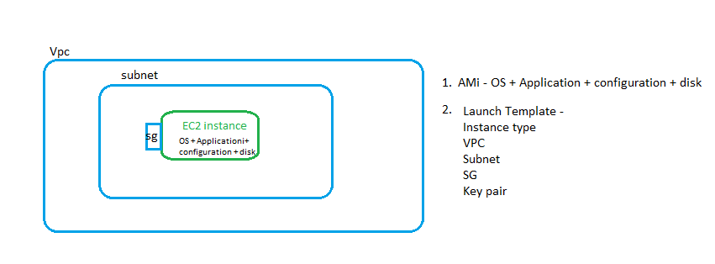
1 .Lets create a server using AMI
1.1 select a server -> actions -> Image and template
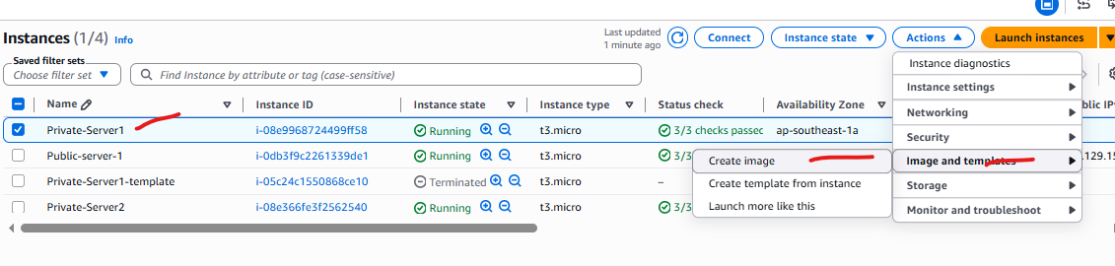
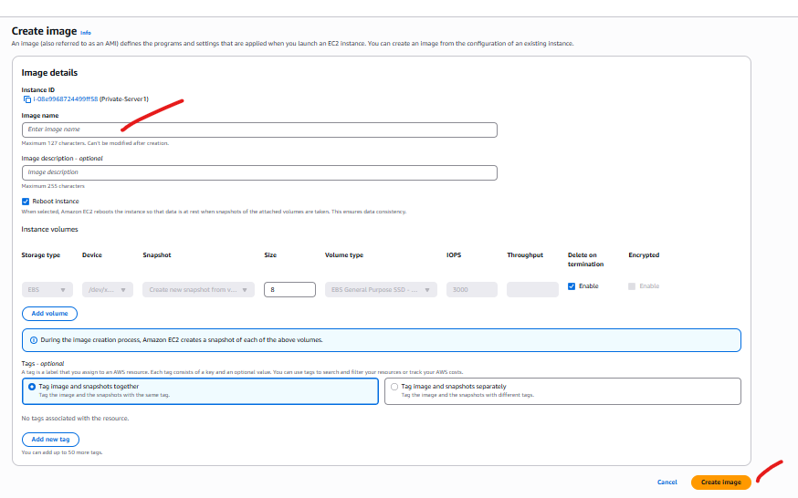
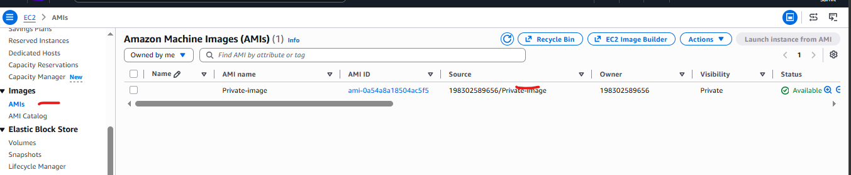

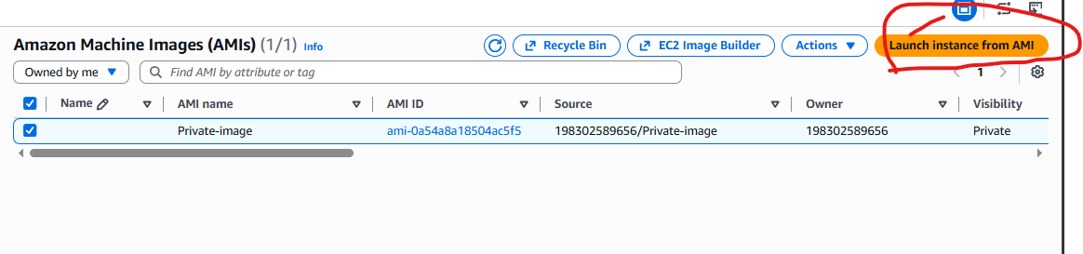

Need to configure name , instance type , Subnet, SG , Private key.
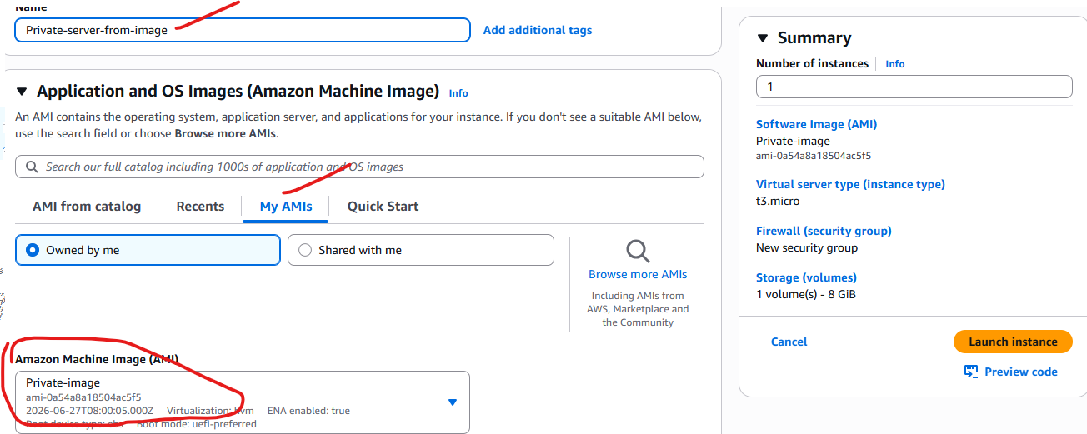

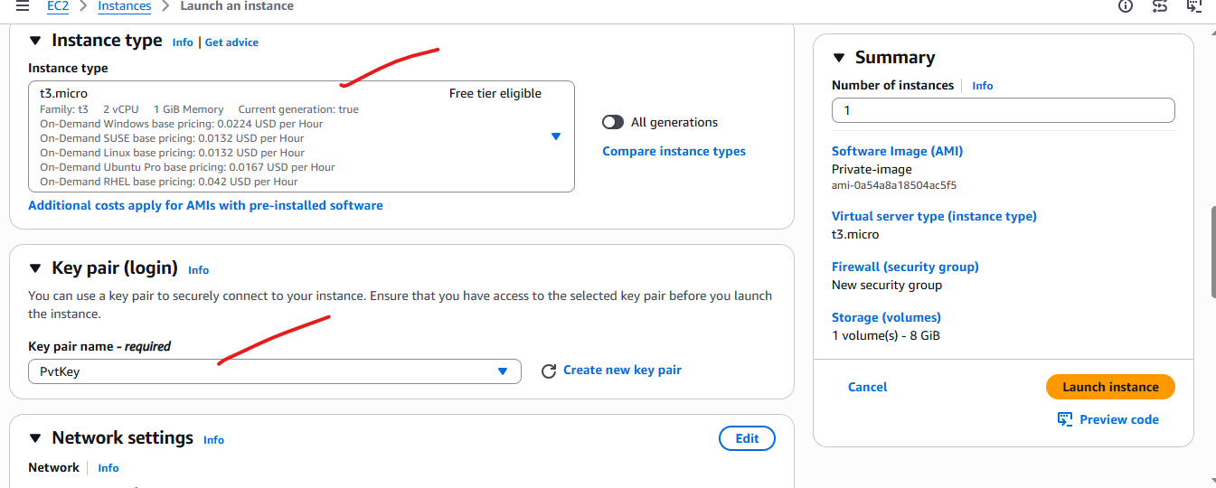
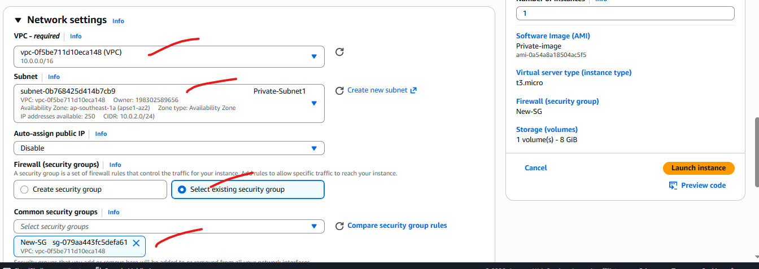

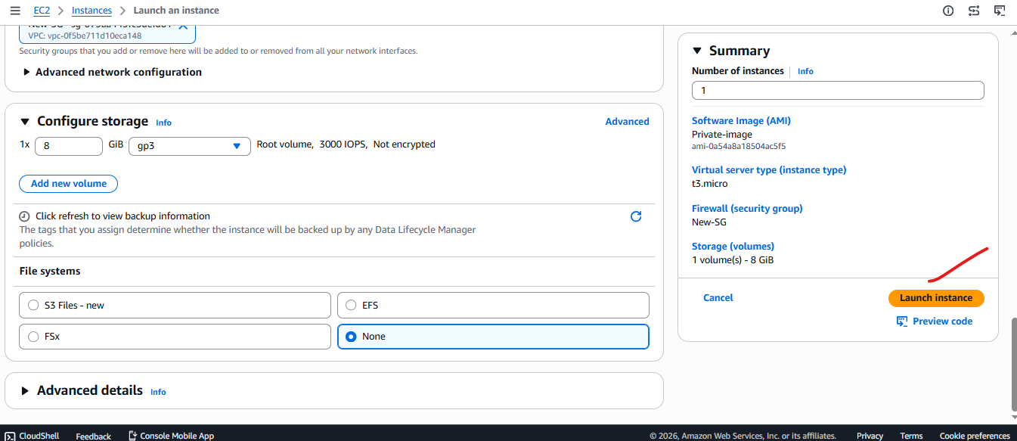

You can see there is a new server created with the name ( Private-Server-from – Image)
